Secondary Crystal Structure: Applications of SCS Theory in Solid State Chemistry and Materials Science

YURI I. VESNIN
Institute of Inorganic Chemistry, Siberian Branch of the Russian Academy of Sciences, Pr. Akademika Lavrentyeva 3, Novosibirsk 630090 (Russia)

Abstract

Some applications of the new theory of secondary crystal structure in solid state chemistry and materials science are considered. A brief description of the main ideas of this theory is presented.

INTRODUCTION

The analysis of a broad massif of experimental facts accumulated by present inevitably leads to the following conclusion. Atomic and molecular structure, though it remains the basis of crystal structure, should be continued and supplemented by one more step of crystal matter organization, namely, secondary crystal structure (SCS). It should be considered as the basis of the secondary structure of condensed matter including amorphous bodies and liquids. The concept of secondary crystal structure is based on the elementary unit - crystal quantum "notion" (Yu. Vesnin, 1970). This notion is to some extent analogous to what a molecule is in chemistry. The elementary unit of a crystal is considered as an individual species, something like a huge molecule of a solid. A consequent theory of the secondary structure of crystal has been built on this basis [1, 2]. This theory has a series of applications in different areas of chemistry and physics of solids. SCS application areas broaden continuously.

THE BASIC NOTIONS OF SCS THEORY

A single crystal consists of elementary units which can be called mics (a mic is a minimum crystal). For inorganic crystals, typical size of a mic is r_{M} = 300 . It contains n_{M} 10⁶-10⁸ atoms (molecules). The shape of a mic in the crystal is a polyhedron, its symmetry and shape being determined by the interatomic interactions. Mics unite into groups (blocks); the groups getting together form single crystal. The gaps between mics in single crystal form a united system which is the T-space of crystal. It is characterized by decreased electron density and changed interatomic distances. The elements of T-space are shown in Fig. 1 (cubic crystal). Here a two-dimensional element is dol, single-dimensional element is lan, and the nod of T-space is yam. The major parameter of the T-spacs (the distance between the adjacent faces оf mics) is a gap as thick as a single atomic layer (it is 2-5 for the majority of inorganic crystals] The parameter is determined experimentally as the interplane distance for the most intensive diffraction reflection.
T-space always contains impurity atoms, intrinsic atoms of the crystal, and free electrons. These atoms form a special type of solid solutions, i. е. displacement solid solutions with maximum atomic (molar) fraction 2-3 %. The theory distinguishes three main types of placement solid solutions, depending on the position of atom in the T-space of crystal. The properties of these solid solutions are in good agreement with the known experimental data [2].
The basic thermodynamic condition of the stability of elementary crystal unit is the minimum in the curve of free energy of the crystal particle versus the number of structural units (atoms, molecules) comprising the particle n at n = n_{M} (Fig. 2). Additional minima of G can appear when mics are united into blocks. For n < n_{М} a crystal particle is a subcrystal. It possesses increased specific energy (energy per one particle) due to the mass deficit with respect to mic mass and the consequent increase of the mutual potential energy of structural units. Because of this, subcrystal is the centre of attraction for atoms and molecules of the environment, or, in other words, the centre of non-specific adsorption (an "active centre"). This conclusion is of principal importance for solid state chemistry and materials science since the creation of active centres is the main method to govern the reactivity of solids. Large number of subcrystals, or active centres, is the reason of high energy saturation of nanophase materials and their special properties. Subcrystals on the surface of a solid determine its adsorption and catalytic properties.
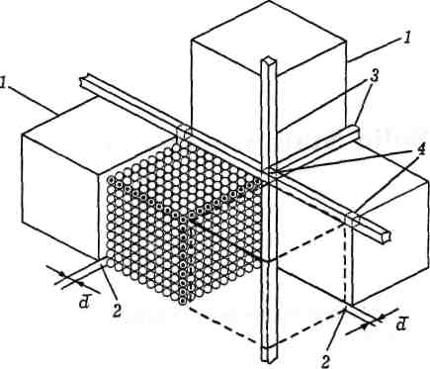
Fig. 1. A fragment of the secondary structure of a cubic crystal and the elements of its T-space: 1 - an elementary unit of crystal, or mic; 2 - a two-dimensional element of T-space, or dol; 3 - a one-dimensional element, or lan; 4 - a nod of T-space - yam; is the parameter of T-space (dol width).

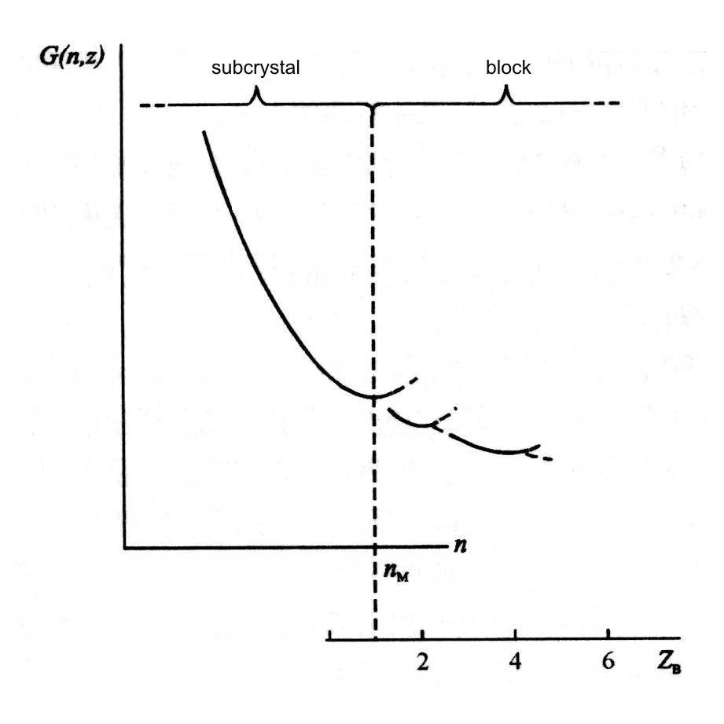
Fig. 2. The dependence of the free energy of a crystal particle on the number n of structural units comprising it (atoms, molecules). The lower scale shows the number of elementary units (mics) in a crystal block.

SUBCRYSTAL AS AN ACTIVE CENTRE OF HETEROGENEOUS CATALYSIS
A subcrystal is the centre of additional centripetal forces for its environment due to the increase of the potential energy of atoms (molecules) comprising the subcrystal, since dU/dx = F where x is the distance from crystal. This is why it attracts and retains the molecules of the environment (gas) thus forming an active sphere around itself. An increased local pressure (concentration) of the surrounding gas medium is created inside this sphere. Under the action of the force field of subcrystal, gas molecules additionally get polarized changing their geometry and energy characteristics of bonds (modifying). Modified molecules react with each other within the active sphere forming the reaction products (heterogeneous catalysis). So, heterogeneous catalysis involves the interaction between the molecules modified in the force field of the active sphere of subcrystal under increased local pressure (concentration) of the components of the environment [2].
The analysis of the known experimental material [3, 4] shows that this model of active centre provides an adequate description of different aspects of heterogeneous catalysis including:
- the activation of catalyst;
- high rates of catalytic reactions;
- the loss of activity after heating the catalysts outside the reaction mixture to temperatures above the Tamman point (subcrystals unite to form elementary units - mics);
- increase of the specific activity for crystallite size r < r_{M} (the volume of the active sphere increases);
- inhibition, poisoning of the catalyst, etc.
A quantitative description of these processes is possible with the development of the methods of SCS theory applied to the active centre model.

ANOMALIES OF THE DISTRIBUTION COEFFICIENT AND CRYSTAL PROPERTIES IN THE REGION OF SMALL CONCENTRATIONS OF ISOMORPHOUS ADMIXTURE

The anomalies of the distribution coefficient K observed when the crystal is grown from the melt (a jump-like increase of K at low concentrations of the isomorphous admixture Х_{B} which is a K-jump) are important for crystallization and purification processes. These anomalies were discovered for many binary systems for the atomic (molecular) fraction Х_{B} < 2-3 % [5, 6]. In order to explain this phenomenon, about ten hypotheses and assumptions have been put forward. However, no generally recognized model exists. On the other hand, some authors [7, 8] report the anomalies in different properties of semiconductor solid solutions within the same concentration range (Х_{B} < 2 %).
The anomalies of different properties of solid solutions at small concentrations of isomorphous admixture are one of the consequences of the SCS theory [9]. As it was mentioned above, impurity atoms and own atoms of crystals are permanently present in the space between elementary units (mics), i. e. in the T-space of single crystal. These atoms form a special class of solid solutions, placement solutions with maximum atomic (molecular) concentration of 2-3 %. While the crystal grows from the melt with admixture concentration Х_{B} = Х₀ < 2-3 %, the mechanism of admixture disposition in crystal can change. At Х_{B} > Х₀ the admixture is mainly in the mics' volume as isomorphous solid solution. For Х_{B} < X₀, due to the decrease of the entropy factor and the increase of free energy G, it is energetically more profitable for impurity atoms to occupy the positions between the mics (T-space) thus forming the displacement solid solution. The transition will occur in the vicinity of the cross point of the concentration curves of the Gibbs energy of mixing ΔG_{mix} = ΔH_{mix} - ТΔS_{mix} (Fig. 3). A necessary condition for this transition is sufficiently large positive ΔH_{mix} of the isomorphous solution. Otherwise the ΔG_{M} curve goes too low and does not form any intersection with the ΔG_{T} curve. The ΔH_{mix} of isomorphous solutions gets positive meaning due to the deformation energy of the lattice which is proportional to ΔR, the difference between atomic radii of the components. Because of this, the K-jump is observed only for rather large ΔR [6]. SCS theory explains all the features of this phenomenon: 1) the occurrence of K-jump as the consequence of the change in the mechanism of impurity disposition; 2) according to [2], the concentration range of K-jump is the region of the existence of disposition solid solutions (not more than 2-3 % of the impurity); 3) increase but not decrease of the concentration of impurity in crystal at X_{B} < X₀; 4) the necessity for rather large difference in atomic radii of isomorphous components ΔR.
The change of the mechanism of impurity disposition in crystal and the type of solid solution can be the reason of the above-mentioned anomalies of crystal properties in the vicinity of X_{b} = X₀. SCS theory allows to estimate the character of these anomalies. A systematic investigation of concentration dependencies of K and crystal properties for the same samples can be important for growth processes and purification of substances by crystallization. Of special interest is a more important case, namely, the distribution of impurity during the crystallization of aqueous solutions (solvent effect).
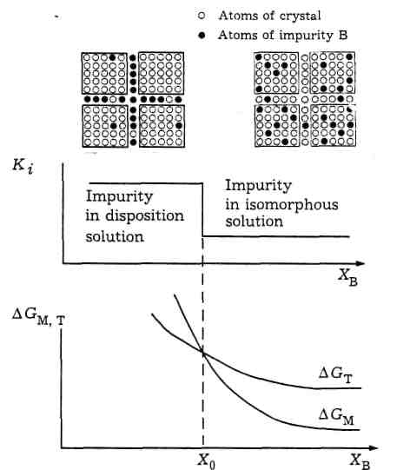
Fig. 3. Concentration curves of the Gibbs energy of mixing and the jump of distribution coefficient in the region of small concentration of isomorphous impurity. ΔG_{M} - isomorphous solutions; ΔG_{T} - placement solutions.

THE DECOMPOSITION OF ISOMORPHOUS SOLID SOLUTIONS (GUINIER - PRESTONE ZONES)
The existence of secondary structure of crystals is clearly exhibited when isomorphous solid solutions decompose. A supersaturated solid solution decomposes with the formation of a new phase. Let us consider this process for cubic mics as an example (see Fig. 1). Atoms present in excess concentrations for the given thermodynamic conditions leave the mic and enter T-space uniformly through all the faces of the mic. Accumulating in the neighbouring dols and lans these atoms form aggregates that act as the nuclei of the new phase. They should possess a maximum symmetry in the dol plane because a maximum symmetry provides the minimum of mutual potential energy of atoms. Because of this, the aggregates are discs with the maximum diameter r_{M} = 300 (mic edge) and thickness 2-5 (gap between the faces). The concentration of discs is equal to the number of mics in 1 cm³ of the crystal multiplied by the mean number of gaps, or C_{d} = 3 10¹⁶ × 3 = 10¹⁷ cm⁻³. The planes of discs are directed as the major crystallographic axes.
Another part of atoms will be accumulated in lans and form aggregates there. Being arranged along the lans they are shaped as needles of the thickness 3-8. It was shown earlier [2] that the diffusion of atoms along the Ian proceeds at an increased rate (rapid diffusion) and needle aggregates easily unite in the direction of diffusion. Because of this, their length should be more than the mic's edge (300 ) and the concentration should be less than the number of lans in 1 cm³, г. e. C_{n} <10¹⁷ cm⁻³. The needles are also directed along the major crystallographic axes. The shapes and positions of aggregates are shown in Fig. 4.

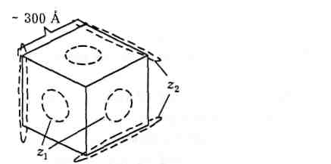

Fig. 4. The precipitation forms of the second phase at the initial stage of the decomposition of isomorphous solid solutions with cubic rnics: z₁ - Guinier - Prestone zones; z₂ - Guinier - Prestone - Bagaryatsky zones.

Table 1 presents a comparison of these conclusions with the data of direct electron microscopic observations of cubic solid solutions (alloys based on Al). These data are rather typical also for other solid solutions [10]. One can see that the conclusions of the SCS theory coincide with experimental data in all the parameters including shapes, sizes, concentrations, and crystallographic orientation. In the theory of dispersion hardening of materials [10] the discs are called Guinier — Prestone zones (GP), needles are the Guinier - Prestone - Bagaryatsky (GPB) zones. These data can be considered as a direct experimental confirmation of the existence of secondary structure of crystals.

TABLE 1
Characteristics of atoms precipitation during the decomposition of solid solutions based on aluminium (the data of [10])

Zone | Shape | Dimensions, | Number in 1 cm | Space orientation | Alloys
GP, type II | Disk | (20 - 200) × (3- 6) | 10¹⁶-10¹⁸ | Main crystallographic axes | А1 - Ag, А1 - Си, Al - Zn, A1 - Zn - Mg
GPB, type II | Needle | ((1-2)⋅103)×(3-10) | 3⋅10¹⁵ | The same | Al - Mg - Si

POLYMORPHOUS TRANSFORMATIONS IN CRYSTALS

Reactivity of crystals at the polymorphous transformation point

The effect of a substantial increase of the crystal reactivity at the polymorphous transformation point (Hedvall effect) is well known and widely used in practice [11]. However, no detailed mechanism had ever been proposed to describe this phenomenon.
From the viewpoint of SCS theory, the polymorphous transformation in crystal (phase 1 → phase 2) involves the destruction of the initial secondary structure of phase 1. If the transformation occurs in the region of relatively low temperatures (slow diffusion), the secondary structure of phase 2 is formed slowly. In this case, the secondary structure should be composed of the subcrystals of phase 2 (crystallite size less than 300). According to [2] (see also Fig. 2), such a crystal possesses increased specific energy and high reactivity. So, from the viewpoint of SCS theory, the mechanism of the Hedvall effect involves the transformation of secondary structure at the point of polymorphous tranformation: mic of phase 1 → sub-crystal of phase 2.

Phase transitions of the II type and hybrid single crystal
It is known that in the case of polymorphous phase transition of the II type in crystal (phase 1 → phase 2) near the transition point the crystal is composed of microregions of the phases 1 and 2 (hybrid single crystal) [12, 13].
According to the SCS theory, long-range order in the crystal is limited by the mic volume [2]. Because of this, structural transformation is initially localized within this volume. When temperature increases, the transformation spreads over the crystal by increasing the number of mics (or subcrystals) of phase 2 due to the decrease of the number of mics of phase 1 (prolonged polymorphous transformation). A hybrid single crystal is formed in which the regions of phases 1 and 2 coexist [12]. The latent heat of transformation 1 → 2 is gradually absorbed during this process. Experimentally this process is exhibited as the apparent increase of specific heat. When the transformation is over, the usual behaviour of specific heat is recovered again (λ-point).

CONCLUSION
The above-mentioned facts, as well as other applications of the SCS theory considered earlier [2], allow us to conclude that this model provides quite an adequate description of different processes in solid. On the other hand, modern model of a solid is built completely at the atomic structure level and does not incorporate secondary structure of a crystal. Such a model is incomplete and cannot depict the reality quite adequately. This resembles the attempts to build up modern chemical models using only atoms and ignoring molecules. In modern chemistry and physics, this inevitably leads to numerous difficulties in the description of crystal properties and worsens the ability of theory to forecast real experiments and foresee new facts and phenomena.

REFERENCES
1 Yu. I. Vesnin, J. Struсt. Chem., 36 (1995) 655.
2 Yu. I. Vesnin, Vtorichnaya struktura i svoystva kristallov, Izd-vo SO RAN, Novosibirsk, 1997.
3 G. K. Boreskov, Geterogenny kataliz, Nauka, Moscow, 1988.
4 J.-E. Germain, Catalyse heterogene, Dunod, Paris, 1959.
5 A. N. Kirgintsev, L. I. Isayenko and V. A. Isayenko, Ras-predeleniye primesi pri napravlennoy kristallizatsii. Nauka. Novosibirsk. 1977.
- L. A. Nisel'son and A. G. Yaroshevsky, Mezhfazovye ko-effitsienty raspredeleniya, Nauka. Moscow, 1992.
- B. F. Ormont. Zhurn. fiz. khimii, 52 (1978) 342.
- Ya. A. Ugay, Yu. M. Bondarev. E. G. Goncharov and A. M. Khoviv, Neorgan. materialy, 23 (1987) 1945.
- Yu. I. Vesnin, Abstr. Europ. Crystallogr. Meeting ECM-18, B3-P8, Praha. 1998.
- A. Kelly and R. B. Nicholson, Precipitation Hardening, Pergamon Press, New York, 1963.
- K. Meyer, Phisikalisch-chemische Kristallographie,Verlag fiir Grundstoffindustrie, Leipzig, 1968.
- A. R. Ubellohde, Melting and Crystal Structure. Clarendon Press, Oxford, 1965.
- A. J. Burggraaf. Ber. Bunsenges. Phys. Chem., 87 (1983) 208.

